# Assessment Task 1 - In-Class Group Workshop Week 2

**Submitted by**

**Sabbir Hasan Rabbi**

**Id: k240175**

1. **Develop a Java Program that allows the user to input their pay and find out 10% from it and display it as a saving.**

To develop this program, first, I created a `Scanner` object to read the user's input. I then prompted the user to enter their pay and stored this value in a variable. After that, I calculated 10% of the entered pay to find the savings amount. Finally, I displayed the calculated savings to the user and closed the `Scanner` to properly manage system resources.

The code:

*//Id: k240175*

*//Sabbir Hasan Rabbi*

import **java.util.Scanner**;

**public** **class**  saving{

**public** **static** **void** main(**String**[] args) {

**Scanner** scanner = new Scanner(System.in);

        System.out.print("Enter your pay: ");

**double** pay = scanner.nextDouble();

**double** savings = pay * 0.10;

        System.out.println("Your savings (10% of your pay) is: $" + savings);

        scanner.close();

    }

}

Display of the output:

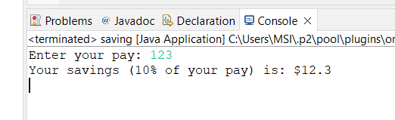

1. **Develop a Java Program that allows the user to input a set of 4 marks. The program calculates and output the total.**

*//Id: k240175*

*//Sabbir Hasan Rabbi*

import **java.util.Scanner**;

**public** **class** TotalMarks {

**public** **static** **void** main(**String**[] args) {

**Scanner** scanner = new Scanner(System.in);

**int** total = 0;

        for (**int** i = 1; i <= 4; i++) {

            System.out.print("Enter mark " + i + ": ");

**int** mark = scanner.nextInt();

            total += mark;

        }

        System.out.println("The total : " + total);

    }

}

The output:

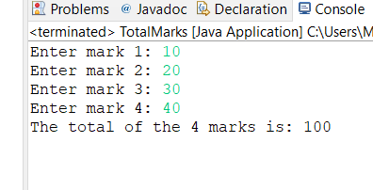

1. **Develop a Java Program that allows the user to enter three values and display the multiplication of all values.**

The java code for this will be :

*//Id: k240175*

*//Sabbir Hasan Rabbi*

import **java.util.Scanner**;

**public** **class** multiplication {

**public** **static** **void** main(**String**[] args) {

**Scanner** scanner = new Scanner(System.in);

**int** total = 1;

        for (**int** i = 1; i <= 3; i++) {

            System.out.print("Enter value " + i + ": ");

**int** mark = scanner.nextInt();

            total *= mark;

        }

        System.out.println("The total : " + total);

  }

}

The output

